CO2 Emissions Considerations for the

Keystone Pipeline and Development of

Tar Sands

Prof. Alexander H. Slocum (slocum@mit.edu)

Massachusetts Institute of Technology

David Taylor (dtaylor@mit.edu)

Massachusetts Institute of Technology

Santiago Paiva (santiago.paiva@mail.mcgill.ca)

McGill University

**Abstract**

In this paper we demonstrate that Government of Alberta can continue to mine and export tar sands while being completely carbon neutral in the future. If 20% of Canadian Tar Sands Oil income were required to be invested, so not a tax, in renewable-based reclamation efforts for the land that is exploited to get the tar sands, then in 35 years we will have more CO2 pulled from the air than put in using wind turbines, or in 20 years if we were to use Photovoltaic solar cells.

Contents

1 Introduction 2

1.1 Motivation 2

1.2 Problem Domain 2

2 Alberta's Tar Sands Oil Overview 4

2.1 Mining and Production of Tar Sands 4

2.2 The Keystone XL Pipeline 4

2.3 Social, Environmental, and Health Impact 5

3 CO2 Saved From Investing in Wind Energy 6

4 CO2 Saved From Investing in Solar Energy 8

5 Hybrid Model: Wind Turbines and PV Solar Cells 9

6 Conclusion 9

References 11

# 1 Introduction

## 1.1 Motivation

Beneath the boreal forest in Northern Canada lies the world's 2nd largest oil reserve, known as the tar sands. The tar sands are a mixture of sand and a heavy crude oil called bitumen. Natural bitumen is reported in 598 deposits in 23 countries, with the largest deposits in Canada, Kazakhstan, and Russia. Bitumen reserves are estimated at 249.67 billion barrels out of which 178 billion barrels (70.8%) are in Canada (Alberta) [1].

The Northern Alberta region contains 98% of the Canadian tar sand oil industry and it is divided into three regions:

* The Athabasca-Wabiskaw deposits region
* The Cold Lake deposits regions
* The Peace River deposits region

Together, they cover 140,200 square kilometers [2].This is equivalent to a region bigger than England. It is also estimated by the Government of Canada that these regions hold proven reserves up to 1.75 trillion barrels of bitumen in place [9]. In addition, 173 billon barrels (10%) estimated to be recoverable at current prices using current technology.

This amounts to 97% of Canadian Oil reserves and 75% of total North American petroleum reserves. It is further estimated that 90% of the Alberta oil sands are too far below the surface to use open-pit mining. As a consequence, the Canadian government has decided the creation of the Keystone XL pipeline which would allow mining companies to get further access to the mineral.

However, it is estimated that the environmental and health factors resulted as a by-product of these pipeline does not outweigh the benefits of building such a pipeline. In this paper, we demonstrate how better alternatives such as investment in Wind Turbines and Photovoltaic (PV) Solar Cells not only will result in a significant reduction of CO2 emissions, but prove to be a solid green option for the future of Alberta and the country.

## 1.2 Problem Domain

Alberta's Tar Sands are being mined over a vast area which will destroy large swaths of forests releasing even more carbon into the atmosphere. Just mining the oil and consuming it could have a huge impact on climate change.

**Hypothesis:**

*The effect on climate change does not have to be negative IF as part of land reclamation of the mined tar sands area, developers of the tar sands resource were required to plan and invest for when the tar sands are depleted. This scenario could include for every square kilometer of land to be reclaimed, a 5 MW wind turbine is installed.*

The figure below shows the cumulative effect over the years of this land reclamation requirement, with 50% of the total tar sands land area being reclaimed with wind turbines. Similar requires are obtained with 10% of the area reclaimed as PV cells power stations (shown in the next section).

**This requires the tar sands developers to invest a portion of sales, $20/bbl for the scenario here, into renewable energy production**; however, they benefit because they can use the electric power for production of the tar sands, and once the number of turbines increases to a point, they can start sending power out on the same lines they initially had installed (are in the process of installing) to develop the tar sands.

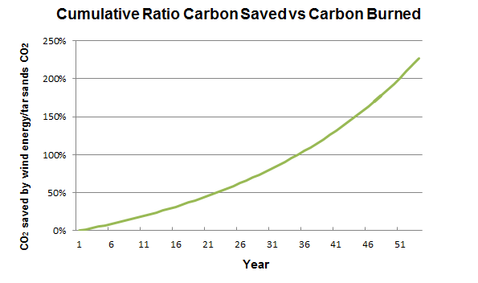

**Figure 1: Amount of CO2 offset by 20% investment in Wind Turbines**

# 

**Figure 2: Amount of CO2 offset by 20% investment in PV Solar Cells**

# 2 Alberta's Tar Sands Oil Overview

## 2.1 Mining and Production of Tar Sands

Per day, tar sands operation release as much CO2 as all the cars in Canada

[8]. Enough natural gas is burned to heat 4 million homes daily, while local upgraders emit 300 tonnes of sulphur. The Athabasca River is part of the third largest watershed in the world. Processing one barrel of bitumen requires approximately three barrels of water [8]. The toxic water is then pumped into giant tailings ponds alongside the shore.

According to a report released in 2011 [3], production of tar sands released an estimated of 47.1 million metric tonnes of CO2 into the air. Considering that in 2011, 1.8 million barrels a day were produced, we obtain the following chart:

**Table 1: CO2 from Tar Sands production and oil use**

|  |  |
| --- | --- |
| **Production** | **Use** |
| Oil produced (million barrels per year) | 693.5 |
| CO2 to produce the oil (megatonnes/year) | 50 |
| CO2 from oil use (megatonnes/year) | 298.2 |
| **Total CO2 from tar sands (megatonnes/year)** | **348** |

The recent announcement of the Keystone XL pipeline would allow the tar sand oil industry to propel mining and production to a whole new level. However, it raises the question: is the proposed Keystone XL pipeline the most environmental friendly option compared to other alternatives? There is a better alternative.

## 2.2 The Keystone XL Pipeline

As mentioned, the pipeline is a major milestone in the next phase of extracting tar sands under Canada's Boreal Forest to reach higher prices of overseas markets.

Projected Impact of Keystone XL by FEIS [4]:

* Projected 830,000 barrels/day flow
* Add between 147 to 168 million metric tons of greenhouse gas emissions annually
* According to FEIS, the pipeline would be \unlikely to significantly impact the rate of extraction in the oil sands, or the continued demand for heavy crude oil at refineries in the United States." Those greenhouse gas emissions from tar sands oil would probably be produced with or without Keystone.

In a recent article by Environment News Service, two senators called on the Secretary of State John Kerry and the Obama Administration to conduct “an immediate and comprehensive study" of the public health risks to communities from the proposed Keystone XL pipeline would carry diluted bitumen from Alberta across the US-Canada border to refineries on the Texas Gulf Coast [5].

We understand Canada's position: tar sands will be mined and melted whether or not Keystone XL ever gets built, but we want to provide a better alternative to achieve that goal.

## 2.3 Social, Environmental, and Health Impact

Some of the issues at hand:

**Water Contamination.**

The article from Bloomberg Businessweek focuses on Canada's Alberta province putting forth man-made lakes, cited to be a by-product of the oil sands industry, with companies including Syncrude Canada, Royal Dutch Shell and ExxonMobil affiliate Imperial Oil running out of room to store the polluted water, a spin-off of the process used to turn bitumen into diesel and other fuels. It discusses the country's plans to build reservoirs filled with tar sands wastewater, which are predicted to cover almost 62,000 acres by 2020 [14]

**Risk of accidents.**

Pipelines spill more often than rail - over the past decade, pipelines have spilled 474,441 barrels of oil, compared to the 2,268 barrels spilled over the same time by rail. Pipeline spills also tend to be larger than rail spills - witness the 2010 Enbridge oil spill, when a burst pipeline led to more than 23,000 barrels of oil pouring into Michigan's Kalamazoo River. Fears over similar accidents have helped put the proposed Keystone XL pipeline on hold (environmentalists have raised concerns that spills involving oil sands crude will be especially difficult to clean). But pipeline spills remain rare as well, and the ones that do occur pose a more direct threat to the environment than to people - unlike rail accidents [15]

**Political view.**

By letting the oil industry influence this process, Secretary (of State John Kerry) is undermining his long-established reputation as a leader in the fight against climate change. President Obama can end this charade; sufficient scientific data exists to justify denying the Keystone XL pipeline. It is a simple matter of having the political will, and courage, to stand up to the oil industry. This decision is a defining moment in his environmental legacy [16]

# 3 CO2 Saved From Investing in Wind Energy

We propose the following scenario:

If we were to put one 5MW wind turbine per kilometer square in a total of

70,100 kilometer square land area (50 % of the Alberta Tar sands area), and invest 20% of the portion of the sales ($20/bbl for this scenario), then this approach would offset the CO2 created by mining and using the tar sands oil in approximately 35 years while producers can benefit from the use of electric power for mining and production of the tar sands.

add to the model the income from the electricity  (how many $/bbl is it equivalent too)?

It is estimated that the CO2 released (and captured) from boreal forest is about 0.0262 tonnes/m2 [13]. This value is small compared to CO2 offset by having a large wind turbine (1192 megatonnes/year by not burning coal to produce energy generated by wind). Therefore, this is a strong motivation for reclamation is not to just replant the forest, but to plant forest *and* a large wind turbine.

The graph below shows different case scenarios for different percentage of investment:

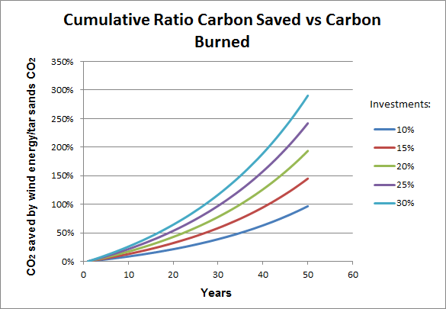

**Figure 3: Amounts of CO2 offset with different investments in Wind Energy**

**Table 2: Amount of CO2 saved by Wind Turbines**

|  |  |
| --- | --- |
| **Description** | **Value** |
| Turbine Peak Power (MW) | 5 |
| Capacity factor | 40% |
| Land area per turbine (km2) | 1 |
| Percent land area for wind turbines | 50 % |
| Area of wind farm (km2) | 70,100 |
| (Square Miles) | 27,383 |
| Square size (miles x miles) | 165 |
| Something | Something |
| Number of turbines to be built for land area | 70,100 |
| Average Power generated (GW) | 198 |
| Average annual energy produced (TWHr) | 1,734 |
| **CO2 saved by wind turbines (megatonnes/year)** | **1,684** |

**The CO2 offset percentage**

The CO2 offset percentage is obtained with the following formula:

$${Carbon}_{offset}= \frac{Amount of CRCS (Cumulative Ratio Carbon Saved)}{Amount of CB (Carbon Burned)}$$

To compute the amount of CRCS (Cumulative Ration Carbon Saved):

$${CRCS}_{t+1} ={CRCS}_{t }+ \frac{{\# installed wind turbines}_{t}}{\# total turbines to be built for land area}× α$$

Where:

* $α= {CO}_{2} saved by not burning coal to produce energy generated by wind$ from Table 2

$t=time (years)$

To compute the amount of CB (Carbon Burned):

$${CB}_{t+1}= \sum_{i=0}^{t}{{CB}_{t}}$$

Where:

* ${CB}_{t}= Total {CO}_{2} per year from tar sands (megatonnes/year)$ from Table 1

**Assumptions:**

1. **Wind Turbine Peak Power**

* The choice of 5 MW/km2 is a conservative output since most turbines are outputting around 7 MW these days.
* Most companies expect installation of 8-10 MW output wind turbines by 2015.
* SeaTitan 10 MW by American Energy Technologies is currently the biggest wind turbine

1. **Wind Turbine Capacity Factor**

* NRELs median capacity factor to be 40% for onshore wind turbines
* New normal wind turbine net capacity factor to 50%
* Capacity factor will increase with time

1. **Land area per turbine**

* Land area assumed to cover 1 km2 per turbine

1. **Percent land area for wind turbines**

* Assumption to cover 50% of the total Alberta tar sands area

# 4 CO2 Saved From Investing in Solar Energy

We propose the following scenario:

If we were to put one 1600mm x 1020mm PV solar panel per 0.00163 kilometer square in a total of 14,020 kilometer square land area (10 % of the Alberta Tar sands area), and invest 20% of the portion of the sales ($20/bbl for this scenario), then this approach would offset the CO2 created by mining and using the tar sands oil in approximately 20 years while producers can benefit from the use of electric power for mining and production of the tar sands.

It is further estimated that if 25% of the portion of the sales ($25/bbl) were to be invested, then this would be achieved in 16 years. The graph below shows different case scenarios for different percentage of investment:

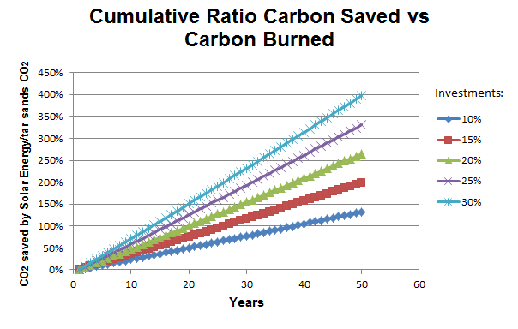

**Figure 4: Amounts of CO2 offset with different investments in Solar Energy**

**Technical details:**

|  |  |
| --- | --- |
| Description | Value |
| Peak power of solar cell (MW) | 0.00130 |
| Percent land area assumed covered by PV fields | 10% |
| Area of PV farm (km2) | 14,020 |
| (Square miles) | 5,477 |
| Square size (miles x miles) | 74 |
| Land area per solar panel (km2) | 0.00163 |
| Number of solar panels to be built for land area | 8,590,686 |
| Density of coverage on land designated for PV fields | 30% |
| Area of PV cells (m2) | 4,206,000,000 |
| PV cell efficiency | 15% |
| Average 24/7 solar insolation April (Wh/m2/day) |  |
| June | 6,250 |
| January | 1,389 |
| Average power (assumes 24/7 operation made possible with storage technology) (GW) |  |
| June | 164 |
| January | 37 |
| Average | 100.405 |
| **CO2 saved by not burning coal to produce energy generated by solar (magatonnes/year)** | **854** |

**Assumptions:**

1. **Peak Power of PV cell**

* Assumption to be 1.3kW solar photovoltaic system. In Alberta, a cell will typically produce between 1000 and 1400 kWh per year [10]

1. **Percent land covered by PV fields**

* Assumption to cover 10% of land area

1. **Land area per solar panel**

* Most solar panels come at roughly two sizes. We assume that this solar panel is 1600mm x 1020mm. [11]

1. **Density of coverage on land designated for PV fields**

* Assumption to cover 30% of land area

1. **Efficiency of PV fields**

* Dave DeGraaff, SunPowers general manager, estimates PV cells efficiency to achieve 23% by 2015
* The Fraunhofer Institute for Solar Energy Systems recently announced the development of a multijunction photovoltaic cell with 44.7% efficiency

1. **Cost of installation of PV fields**

* Estimated to be $38,000 per panel [12]

# 5 Hybrid Model: Wind Turbines and PV Solar Cells

We are interested in combining a hybrid model where we would have a percentage of the Alberta’s tar sand area with wind turbines and solar PV cells. Factors to take into account include the shadow produced by the wind turbine and the terrain elevation.

# 6 Time Series Analysis

Time Series of Oil Sand price per barrel

Time Series of CO2 released

Time Series of Wind

Time Series of Solar

# 7 Conclusion

As soon as possible, begin test project to install 10 wind turbines on reclaimed land and study the project to learn costs and issues with respect to ultimately widespread application of this reclamation strategy.

In parallel, conduct a detailed business analysis (short and long term return of investment ROI) of the hypotheses presented here, including:

1. The requirement of investing 20% of income from tar sands into renewables to provide electricity for processing the tar sands, and then selling excess electricity back to the grid.
2. The ability of a) above to encourage the US to approve of the Keystone pipeline
3. The time effect cost of releasing a lot more CO2 now in exchange for a long term greater reduction.

It is thus proposed:

1. Delay Keystone pipeline decision for 12 months while the experiment is run
2. As soon as possible, begin test project to install 10 wind turbines on reclaimed land and study the project to learn costs and issues with respect to ultimately widespread application of this reclamation strategy.
3. Along the Keystone pipeline right of way in the US, the US Government will study installation of power transmission lines to enable farmers to develop their wind resources to the fullest ability, independent of existing obstructionist power generation regulations.

# References

[1] Attanasi, Emil D.; Meyer, Richard F. [*"Natural Bitumen and Extra-Heavy Oil*"](http://www.worldenergy.org/documents/ser_2010_report_1.pdf) (PDF). Survey of energy resources (22 ed.). [World Energy Council](http://en.wikipedia.org/wiki/World_Energy_Council). pp. 123–140. 2010.

[2] *About Oil Sands: Facts and Statistics*. Retrieved March 13, 2014, from

http://www.energy.alberta.ca/oilsands/791.asp

[3] http://www.scientificamerican.com/article/tar-sands-and-keystone-xl-pipeline-impact-on-global-warming/

[4] U.S Department of State. *The final environmental impact statement*

*(FEIS).* January 2014

[5] Prystupa, Mychaylo. *Alberta doctor tells U.S.: Canada is lying about tar*

*sands health effects*. Retrieved Feb 27, 2014, from

https://www.vancouverobserver.com/news/

[6] *Oil Shale/Tar Sands Guide.* Retrieved March 13, 2014, from

http://ostseis.anl.gov/guide/tarsands/index.cfm

[7] R.D White (Robert Douglas), *Global Environmental Harm: Criminal Per-*

*pectives*. Cullompton, Devon; Portland, Or.: Willan Pub. 2010.

[8] Mettler, Peter. *Petropolis: Aerial Perspectives on the Alberta Tar Sands.*

Documentary. 2009.

[9] [*Alberta's Oil Sands: Opportunity, Balance*](http://www.environment.alberta.ca/documents/Oil_Sands_Opportunity_Balance.pdf). Government of Alberta. March 2008. Retrieved March 19, 2014.

# [10] Leach, Andrew. [*ENMAX solar power – a different definition of affordable*](http://andrewleach.ca/climate-change/enmax-has-a-different-definition-of-affordable-than-i-do/)*.* Retrieved March 19, 2014. http://andrewleach.ca.

[11] *Solar Panel Dimensions*. Retrieved March 19, 2014. http://greenforcesolar.com.au

[12] Korosec, Kirsten. *97% of American Overestimate Cost of Installing Solar*. Retrieved March 19, 2014. http://www.smartplanet.com/

[13] *Carbon Sequestration Facts.* Retrieved March 19, 2014. http://www.forestecologynetwork.org.

[14] Loon, Jeremy Van. *Land of Tar Lakes.* Bloomberg Businessweek November 2013, Issue 4356, p15-16.

[15] Walsh, Bryan. *North Dakota Derailment Shows Dark Side of America's Oil Boom.* Time.com January 2014, p1-1-1

[16] Walsh, Bryan. *Report Raises No Major Climate Objections to Keystone Pipeline, But the Choice Is Obama's.* Time.com January 2014, p1-1-1